LAB NO 02
Lab Report: GPIO Programming & ATmega328P Architecture



Fall 2026

Embedded Systems Lab

Submitted by: Naveed Ahmad
Registration No.: 22PWCSE2165
Class Section: B

Student Signature: ______________

Submitted to:
Eng: Shahzad
Feb 25, 2026

Department of Computer Systems Engineering
University of Engineering and Technology, Peshawar

1. Lab Title

GPIO Programming & ATmega328P Architecture

2. Objectives:
- To understand the GPIO (General Purpose Input/Output) architecture of the ATmega328P.
- To learn register-level programming using Data Direction Registers (DDRx), Port Registers (PORTx), and Port Input Pins (PINx).
- To implement a hardware control loop where a pushbutton controls the state of an LED without using high-level Arduino libraries (like digitalWrite).

- Apparatus / Components:
- Arduino Uno (ATmega328P based)
- 1x LED (Red)
- 1x Resistor (220Ω - 1kΩ)
- 1x Pushbutton
- Connecting wires
- Tinkercad Simulation Environment

- Theory (Concise):
The ATmega328P controls its pins through three primary 8-bit registers:
- DDRx (Data Direction Register): Configures a pin as either Input (0) or Output (1).
- PORTx (Port Register): Sets a pin High (1) or Low (0) when configured as output. If configured as input, writing a 1 enables the internal pull-up resistor.
- PINx (Port Input Pins): Used to read the logical value of an input pin.
In this lab, we use Port B (Pin 8-13) and Port D (Pin 0-7). Specifically, PB0 (Digital Pin 8) is used for the LED, and PD7 (Digital Pin 7) is used for the button.

5. Circuit Diagram:
The circuit consists of:
- LED Circuit: An LED connected to Digital Pin 8 (PB0) in series with a current-limiting resistor, terminating at Ground (GND).
- Switch Circuit: A pushbutton connected between Digital Pin 7 (PD7) and Ground (GND). The code enables the internal pull-up resistor to ensure a stable "High" state when the button is not pressed.
Diagram:
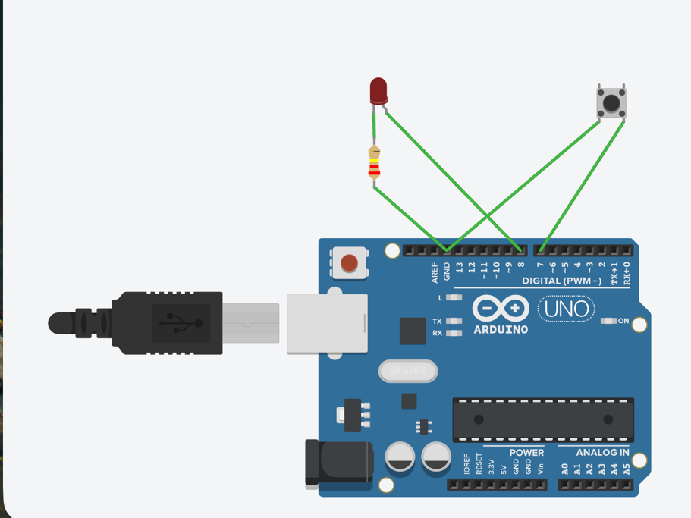

6. Algorithm:
- Initialize Hardware:
- Set the bit corresponding to PB0 in DDRB to 1 (Output).
- Clear the bit corresponding to PD7 in DDRD to 0 (Input).
- Set the bit corresponding to PD7 in PORTD to 1 to enable the Internal Pull-up.
- Main Loop:
- Read the state of PIND bit 7.
- If bit 7 is 0 (Button pressed/grounded):
- Set PORTB bit 0 to 1 (Turn LED ON).
- Else (Button not pressed):
- Clear PORTB bit 0 to 0 (Turn LED OFF).
- Repeat indefinitely
7. Code and Simulation on Thinkercad:
Code:
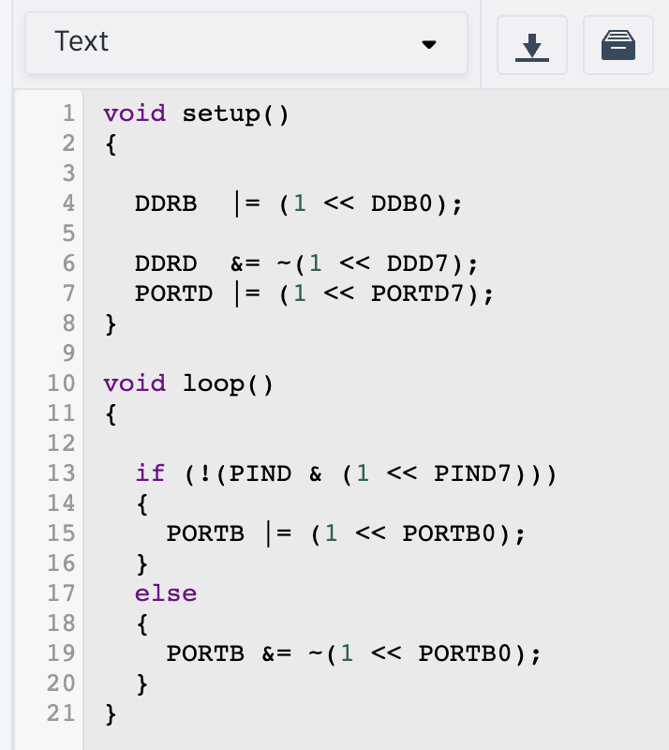

Simulation:
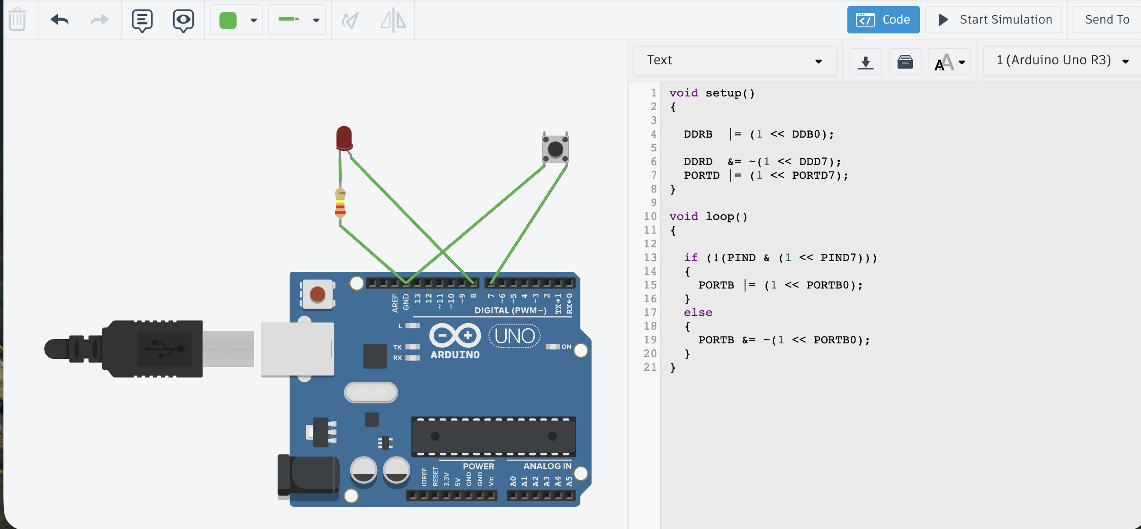

8. Procedure
- Access the Tinkercad circuit simulator.
- Place an Arduino Uno on the workspace.
- Connect the cathode of the LED to GND and the anode to Digital Pin 8 via a resistor.
- Connect one terminal of the pushbutton to GND and the other to Digital Pin 7.
- Open the Code editor, switch to Text mode, and enter the register-level C code provided above.
- Click Start Simulation.
- Interact with the pushbutton and observe the LED response.

9. Observations & Results
- Initial State: When the simulation starts, the LED remains OFF. This is because the internal pull-up resistor keeps PD7 at a logic HIGH (1).
- Button Pressed: When the button is clicked, PD7 is shorted to Ground. The if condition !(PIND & (1 << PIND7)) becomes true, and the LED on PB0 turns ON.
- Button Released: The LED turns OFF immediately upon release.
- Result: The logic correctly identifies the active-low signal from the button to toggle the output.

10. Conclusion
This lab successfully demonstrated GPIO manipulation using direct register access. This method is more efficient than standard Arduino functions as it reduces CPU overhead and allows for simultaneous pin manipulation. We confirmed that the DDRx register correctly handles direction, and PORTx/PINx registers effectively manage state and input sensing.

